GUIDE TO BEING A
YOUNG
MEMBER BOARD REPRESENTATIVE

CONTENTS

Part One
What is the Young Members Board? Page 2 Young Members Board structure Page 3
What does the Young Members Board do? Page 4

Part Two
What are the boards of the IMechE? Page 5
UK Regions Page 7
International Regions Page 8
Divisions and Groups Page 9

Part Three
Roles of the members of the Young Members Board Page 10
Expenses process Page 12

Part Four
Staying in touch Page 13

Appendices
Terms of reference Page 14

PART ONE:
WHAT IS THE YOUNG MEMBER’S BOARD?

Who are the IMechE ‘Young Members’?
Young Members of the Institution are any Affiliate, Associate and Members who have achieved professional registration within the last 10 years. There are over 79,000 young members in the Institution.

Who do the Young Members Board represent?
The YMB represent all young members worldwide. The YMB is formed of over 40 members representing UK & International Regions, Divisions & Groups, and other Institution Boards.
Each representative communicates what is going on in their area of the IMechE and together the board work on projects that support the main IMechE strategy.

Who runs the board?
The YMB is supported by the Member Engagement department through:
- Technical support on using IMechE systems (e.g. access to the contacts database and email systems.
- Linking members up with relevant members/staff
- Support projects and funding
- Answering general queries

How often do the YMB meet?
The YMB meet four times a year. These meetings normally take place in February, May, August and November. The meeting in February is on a weekend away from London and looks at delivering the strategy from the past year to what can be done for the upcoming year. The other three meetings will typically take place at One Birdcage Walk on a Friday afternoon. Since 2020 these meetings have been conducted within either a virtual or hybrid format. This will be revised on an ongoing basis
It is hoped all reps can attend all four meetings each year, If reps cannot make more than one meeting a year we will look at options to help attendance and if not, ask you to step down. Please see ‘Terms of Reference’ in Appendix 1.
In between each meeting it is hoped reps will help complete tasks set and contribute to discussions.

Where do the YMB sit within the Institution?
The YMB report to the Trustee Board.

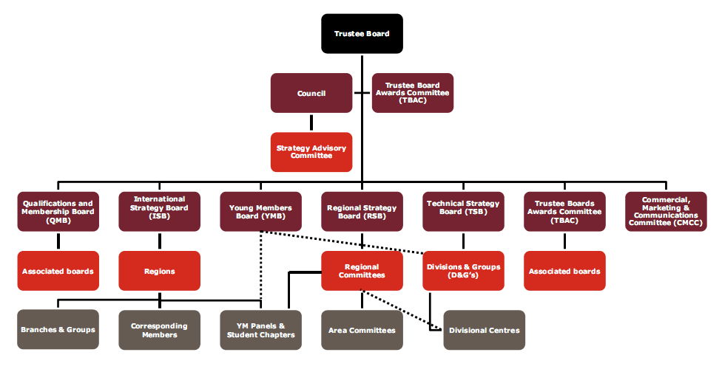
YMB within the IMechE structure
Education and Skills Strategy Board (ESSB)
You Are Here
IYMC

What does the YMB do?
The young members board bids for money every year from the Trustee Board. They use this money to run a series of projects devised from the main IMechE strategy. These can include things like the running and marketing of the global engineering debate or costs to send members to a certain event eg Formula Student to promote membership. Other projects do not cost eg writing toolkits to help other volunteers or bringing issues up to the main senior boards that affect the young members.
It is the responsibility of each rep to either push an objective out to their constituents or to work with the central board working group to complete an action.

The YMB devise their own strategy and this is distributed to all reps in January after discussions at the November meeting. The strategy weekend in February is used to develop the points on the Strategy.
Everyone gets to have a say on the future goals of the YMB.

YMB Priorities
The YMB is part of the Institution's Learned Society:
- Engage existing Young Members
- Inform and engage prospective members/ wider public
The YMB does this by creating a portfolio of engaging events and opportunities to depict the benefit of entering the profession and becoming chartered.

The YMB focuses on 4 of the 12 Learned Society Attributes:
- Member engagement through an event and digital programme of engineering content that also excites non-members
- Links to industry and employers to ensure business relevance of the programme
- A system across the Institution to recognise personal achievement and raise profile
- Promotes professional development of members

PART TWO:
THE INSTITUTION

Trustee Board
The Trustee Board is responsible for the governance and control of the Institution. The President is the Chair. Trustees are elected from the Corporate Members of the Institution and elections are held every year. The Trustee Board meets on average nine times a year and Trustees are expected to attend most if not all of the Board meetings. It is also customary for Trustees to attend Council meetings
The responsibilities of Trustees are as laid down by the Charity Commission and the Royal Charter and By-laws of the Institution, together with the Trustee Role Profile and Code of Conduct.
In addition to the above:
The President holds office for one year. The President-Elect holds office for one year and then becomes our President.
The President–Elect and Vice-Presidents are expected to chair one of the key boards, to also serve on a board or committee, to head various studies, to represent the President at events or visits, and to represent IMechE on external boards and committees. Ordinary members are expected to serve on one or more of the key boards.

Council
Council provides guidance and advice to the Trustee Board on matters related to strategy, the Institution’s membership and other relevant issues.
Council meets on average three times a year with virtual meetings arranged as and when required. The YMB exec team attend Council.

Trustee Board Awards Committee (TBAC)
The main function of the Trustee Board Awards Committee (TBAC) is to recommend policy and to administer the disbursement of all Prizes and Awards, Scholarships, Fellowships and Grants, which stem from the Institution’s Trust Funds.
The YMB has responsibility for the promotion of the James Bates Grant for technical visits by any young member group. The grant will pay for half the total amount of the trip and a report must be written after the event for the TBAC to see how the grant was spent.

Regional Strategy Board (RSB)
The Regional Strategy Board (RSB) represents the active UK and Ireland Regional network, reporting directly to Trustee Board.
RSB is one of the main Boards of the Institution. The Board receives direct HQ support from the Member Engagement department. Together, the Regional network delivers an enormous variety of events, services and community engagement projects that contribute directly to IMechE’s strategy.
It also aims to develop, review and co-ordinate the strategies and activities of the various Region, Area and Young Member Panels which support the Institution’s vision and strategic objectives.
The RSB meet four times a year.

International Strategy Board (ISB)
This is made up of the international region and branch chairs of the international members. The Institution has more than 20,000 members based outside the UK and this number is growing all the time.
The ISB rely on active volunteers to support the membership, acting as representatives of the Institution and the worldwide engineering community. This means they need different support to the UK.

Technical Strategy Board (TSB)
This board is made up of all the chairs of each division and group.
The TSB has a role to lead and share best practice of the division and group event programme.

Who are the UK regions?
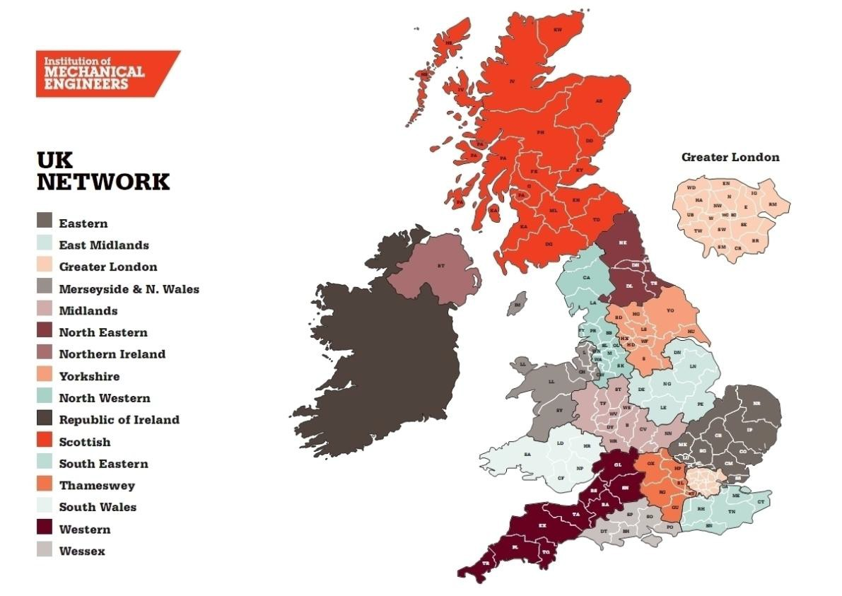
If you are unfamiliar with the regions it may help you to see the map of our 16 UK regions. Each region has one committee that oversees the areas and young member panels within it. Some areas have direct YM panels attached, some run independently.
Regions differ in size with some having one young member panel to four or five. For example Scotland is one region and has young member panels in Glasgow, Edinburgh, Aberdeen and Inverness. One YMB rep looks after all of them.
The UK regions are run entirely by volunteers with only one member of staff devoted to them in the Governance and Engagement department.
Each regional chair will attend the regional strategy board.

Where are the international regions?

There are seven international regions. Each region has a Chair and committee much like the UK setup, but as you can see from the map below they are very large areas. The regional committees operate out of the areas where there are higher groups of members. For countries with not many members there are country representatives who can answer local queries. Each regional chair will attend the International Strategy Board.

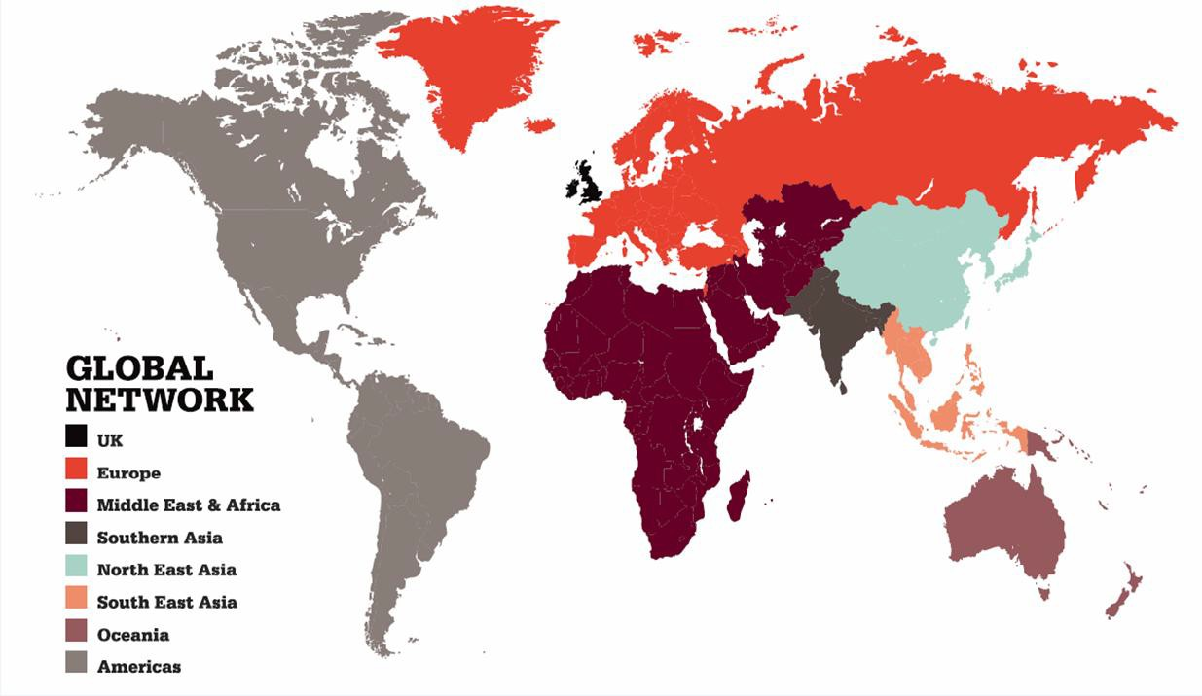

For any international queries email international@imeche.org

What are the Division and Groups?
Divisions are the primary exploiters, implementers and disseminators for their industry sector, and will provide members with up-to-date information on all technical and engineering advancements.

Aerospace
Automobile
Construction & Building Services
Manufacturing
Medical Engineering Power
Process Railway

Groups are the technical and scientific leaders of the Institution, and work throughout a wide range of industry sectors, ensuring engineers are kept abreast of the latest developments from particular specialism.
Combustion Engines and Fuels
Energy, Environment and Sustainability Fluid Machinery
Mechatronics, Informatics and Control Pressure Systems
Safety and Reliability
Structural Technology and Materials Thermofluids
Tribology

Each of these divisions and groups form committees and advise and help organise the events that are run through the Engineering Programmes department. The YMB should have a rep from each one of the above sections.
Division and Groups also have centres around the UK in centres of industry such as an automotive in the north east and railway in the midlands.

PART THREE
WHAT IS INVOLVED IN BEING A YMB REP?

Executive Committee
The main function of the Executive Committee is to represent the views and matters of Young Members and ensure that they are heard, listened to and acted on.
The Executive Committee also ensures that the YMB achieves its aims as stipulated in the YMB’s Terms of Reference and delivers the YMB business plan.

The Executive Committee shall consist of the following Young Members:
- Chair
- Chair- Elect
- Two Vice-Chairs
- YMB Trustee Board Representative

All YMB Executives also sit on Council and are invited to attend the two Council meetings per year.

Role of the Chair
The Chair is responsible for chairing both YMB and Executive Committee meetings. The Chair will also represent the YMB at key activities. The YMB Chair is committed to attend all three annual YMB meetings, the YMB strategy weekend and any other activities or functions as required. It is the responsibility of the Chair to ensure that the YMB Annual Report and any YM issues are presented to the Trustee Board.
Role of the Chair Elect
The Chair – Elect will be expected to work alongside the Chair to improve knowledge of how the YMB works in order to succeed as Chair the following year.

Role of the Vice-Chair’s
The Vice-Chair’s act as representatives of the YMB and make recommendations on behalf of all young members. They are there to lead the board through its annual objectives, and input into the strategic activities. They are also expected to deputise for the Chair or Chair-Elect as required.

YMB Trustee Board Representative
The Trustee Board is responsible for the overall governance of the Institution. It consists of 12 Trustees including the President, Deputy Presidents, Vice Presidents and Ordinary Members. There is currently one Young Member (YM) representative on the board who represents all YM’s of the Institution. It has been decided that a Young Member Board co-opted role should be created on the Trustee Board so that Young Members are proportionately represented.

Role of a Regional Representative
Each Region within the UK has one seat on the Young Members Board. The role of a Regional Representative is to:
- Provide a key link between the Young Members (YMs) in your region and headquarters
- Educate all members on the role of Young Member Panels (YMPs) and the Young Members Board (YMB)
- Take the YMB strategy and help YM’s in the regions with its delivery

Role of Division or Group Representative
Groups are the technical and scientific leaders of the Institution and work throughout a wide range of industry sectors, ensuring engineers are kept abreast of the latest developments from particular specialisms. The Young Members Board has one seat for each Division or Group (D&G). The role of a D&G Representative is to:
- Represent Young Members within your D&G and act as a first point of contact relating to Young Members for your Group
- Educate all members on the role of Young Member Panels (YMPs) and the Young Members Board (YMB)
- Take the YMB strategy and help YM’s in your Group with its delivery

Role of a Consultative Committee Representative
To attend relevant committee meetings, to read their minutes and put forward YM views
  - To fill in YMB feedback form associated with what your committee have been working on in time for YMB meetings and to send in or bring in person
  - To input to YMB strategy and complete actions set by a working group leader
  - To report back to relevant committee about what the YMB have been working on and how they can help

Expenses

It is your responsibility as a rep to claim expenses after a meeting has taken place. Your expenses need to be claimed within four weeks of the meeting and will take approximately four weeks to be processed.

Claims can be emailed to Katherine.hayes@imeche.org

PART FOUR
HOW CAN I STAY IN TOUCH?

Main social media sites of the YMB
Like us on Facebook - www.facebook.com/IMechEYM

Make friends with YMB rep – ‘Robert Stephenson’. If you have an IMechE group make him an admin as well www.facebook.com/IMechE.YMB

www.linkedin.com – search ‘IMechE young members’ to join the group www.twitter.com/imeche_ymb

Websites
http://www.imeche.org/about-us/imeche-governance/young-members-board-representatives this will tell you who all the reps are, the executive team as well as the latest newsletters

Contact us
Young Member Executive at HQ: Katherine.hayes@imeche.org

YMB Chair: ymbchair@imechenearyou.org

Chair Elect: ymbchairelect@imechenearyou.org
APPENDIX 1
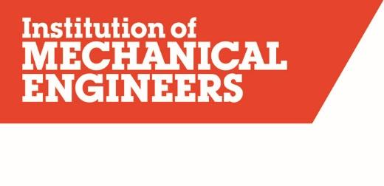

YOUNG MEMBERS BOARD

CONSTITUTION AND TERMS OF REFERENCE

1. Introduction
The Committee shall be called the Young Members Board (YMB).

2. Objectives
The YMB is part of the Institution's Learned Society. As such its main objectives are to engage existing Young Members, and inform and engage prospective members and the wider public alike.

Furthermore, the YMB is to: represent and communicate with Young Members of the Institution; consider all matters relating to Young Members; ensure that Young Member issues are represented on the Trustee Board and ensure that the Institution looks to the future of Mechanical Engineering.

3. Accountability
The YMB is accountable to the Trustee Board. The Trustee Board Representative shall represent the YMB on the Trustee Board.

4. Composition
4.1 | The Board will comprise the following members:
The YMB Executive:
- The Chair
- The Chair-Elect
- Two Vice-Chairs
- The Trustee Board Representative
Region and Branch Representatives:
- One Representative nominated by Young Member Panels in each UK Region.
Representatives to Main Operating Boards:
- One Representative elected by the Board for each of the Institution’s main operating Boards (RSB, TSB, ISB, QMB & ESSB), to which they become an ex-officio member.
International Region Representatives:
- One Representative nominated by Young Member Panels or Regional Committees in each International Region.
Division and Group Representatives:
- One Representative nominated by each Divisional Board and Group Committee.
Consultative Committee Representatives:
- One Representative appointed by the Board for each of the Institution’s main operating Committees & Steering Groups, to which they become an ex-officio member.

One Representative of the Student Advisory Panel.
Specialist and Co-Opted Members:
- One Representative appointed by the Board to represent Young Member Engineering Technicians, and those working towards EngTech status.
- Up to three co-opted members appointed by the Board.
Ex-officio non-voting members:
- The immediate Past-Chair
- Any Trustee as designated by the Trustee Board

Where the representative cannot attend a substitute nominated by the YM will attend in their place
4.2 | Terms of office:  - The Chair-Elect will usually be elected for a term of one year; after completion of the first year, they will usually succeed as Chair.  - The Chair will usually be elected for a term of one year; after completion of the first year, they will usually succeed as Past–Chair.  - The two Vice-Chairs will usually be elected for a term of two years; after completion of the first year, an early end of term is allowed should they be elected as Chair-Elect  - The Trustee Board Representative shall usually be elected for a term of one year.  - The immediate Past-Chair shall usually remain as an ex-officio member of the Board for a term of one year.  - The representatives to the main operating Boards shall usually be elected for a term of two years.  - All other Board Representatives shall usually be nominated/appointed to the Board for a term of one year. There is no limit to the number of terms that a Board member can be re-elected/nominated/appointed for.  - Board members shall be elected/nominated/appointed from members who, within the starting year of office (i.e. the Institution year of office: May-May) are classified as Young Members in line with Institution guidelines.  - Any Board member who ceases to be a Young Member during their term of office may remain in office for one further term, with the agreement of the Board, following the end of that term.  - Any Chair, Chair-Elect, Vice-Chair or Trustee Board Representative who ceases to be a Young Member during their term of office may remain in office for one further term providing they are re-elected by the Board.
4.3 | Nominations and elections for the YMB Executive shall usually take place annually, with the elections taking place at the AGM and voting open to all Young Members.
4.4 | In the event that a member of the YMB Executive fails to adhere to their agreed role criteria, the YMB shall be able to raise a motion of no confidence, which if successfully passed (by an absolute majority of 50% of serving members of the YMB) will remove that member from the YMB Executive.
4.5 | In the event that the YMB Executive becomes incomplete as a result of elections, or otherwise, an election may be held at the following YMB meeting, with terms of service adjusted to align with the Institution year (May-May).
4.6 | Nominations and elections for the representatives to the main operating Boards shall usually take place bi-annually, with the elections taking place at the AGM and voting open to the YMB members.
4.7 | In the event that the YMB no longer has a representative to one of the main operating Boards, an extraordinary election may be held at the following YMB meeting, with terms of service adjusted to align with the Institution year (May-May).
4.8 | Board membership and attendance shall be monitored by the YMB executive to ensure the Board meets this requirement.  In the event of consistent non-attendance:  - In the event of a change in circumstances resulting in a member being unable to attend meetings going forward, a board member should inform the YMB Chair and a delegate provided whenever possible  - If a board member has been unable to attend ≥75% of the meetings in one calendar year, without apologies or a delegate provided, the YMB Chair shall usually initiate succession planning with that individual

5. Quorum
The Chair, or in his/her absence another member of the YMB Executive and one third of serving Board members shall constitute a quorum.

6. Terms of Reference
The Board’s duties are:

To report and make recommendations to the Trustee Board as may be necessary.
- To facilitate the application of Trustee Board decisions where applicable.
- To consider such matters as directed by the Trustee Board.
- To support and guide the activities of Young Members through the Volunteer Network.
- To have responsibility for and attend the Young Members Board Strategy Conference.
- To oversee the activities of the Young Members Board Executive team.
- To support strategies and activities to attract and engage new members to the Institution.
- To support strategies and activities to inspire young people about engineering.
- To be representative of the Young Member membership throughout the organisation, including internationally.

7. Meetings
The Board shall meet no less than three times a year.
The last Board meeting held in an Institution year shall be considered the Annual General Meeting (AGM).
The Board shall hold an annual Strategy Conference.
The Board shall hold elections for the YMB Executive as necessary.

