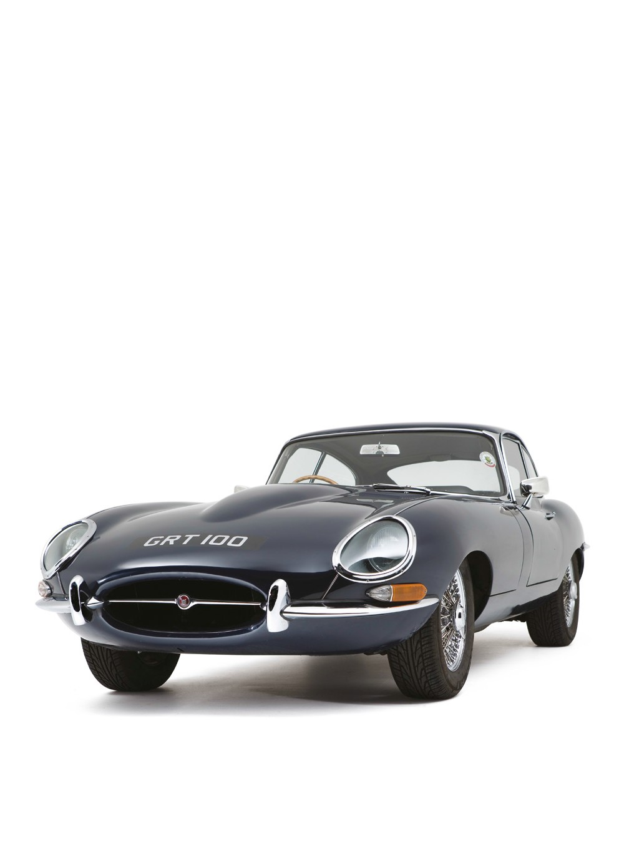
ENGINEERING HERITAGE AWARDS CRITERIA AND APPLICATION FORM.

Improving the world through engineering

Background to the Engineering Heritage Awards

The Engineering Heritage Awards (EHA) were established in 1984 to celebrate excellence in mechanical engineering. The unique strength of the Awards enables the Institution, the recipient
organisation and the profession as a whole to benefit by increasing public awareness of engineering, past, present and future.

The Awards scheme is operated by the Institution’s Heritage Committee. Its remit is to use the
many channels of the Institution to promote the importance of engineering to members, media, MPs and the public at large. Through the understanding of past engineering achievements, the Committee hopes to inspire and educate people on the value of engineering in today’s society.

The Awards

The Heritage Committee has presented Awards to a wide range of engineering achievements, such as pumping stations, trains, aeroplanes, brickworks and submarines. The Committee will consider
any submission from a person, company, society or museum so long as the application has been completed in full.

A full list of the Awards can be found at www.imeche.org/eha or on Wikipedia (search Engineering Heritage Award).

Benefits to the Recipient

The Institution promotes the presentation of a new award to the widest audience possible. In 2011 alone, the awards were featured in 13 radio and television broadcasts and 124 news articles – including articles in The Times, The Telegraph and on the BBC website.

Benefits to an EHA recipient include:
- Your artefact, collection or site will be added to the Engineering Heritage Awards book.
- Inclusion in the Institution heritage website, iPhone heritage app (now with over 50,000 users) and Wikipedia page.
- Presentation opportunity for the Award at your venue. The presentation allows you to showcase your artefact/site to the media, local dignitaries, benefactors and members of the Institution.
- Access to the EHA Recipient Club and future opportunities to network, inform and support other recipients.

Award Criteria

To qualify for an Award, the receiving artefact, location, collection or landmark (known as the Recipient) must demonstrate at least one of the following:

- A unique feature:
  - First of a kind
  - Last of a kind
  - Oldest in existence
  - Only surviving example.
- Industrial innovation – the Recipient has made a contribution to society, industry, production etc.
- A facet of mechanical engineering, or association with a person or event, that has made a significant contribution to society and/or engineering.
- The Recipient is regarded as significant compared to other similar artefacts.

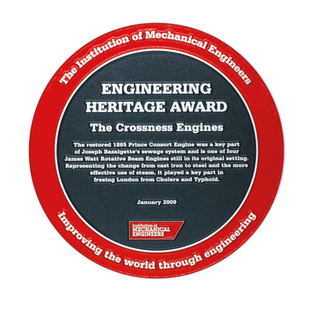
- This Recipient deserves national recognition.

Submitting an Engineering Heritage Award Application

An Engineering Heritage Award application form can be downloaded from www.imeche.org/eha. The following points should be noted before submitting an application:
- Any person, company, museum, society, academic establishment etc can submit an Engineering Heritage Award application to the Heritage Committee.
- For IMechE members: Any member, Division, Group, Region can submit an application for an Engineering Heritage Award. Applications are no longer required to be made via an Institution Committee.
- It is essential that the owners or guardians of the Recipient are aware of your intentions to submit an application. If the Recipient organisation is not aware of the EHA application, the Committee will not review the application.
- The application form must be completed in full.
Any sections which are incomplete will delay the
decision-making process.
- A justification for why the Recipient should receive an EHA must accompany the application. This should be between two and five pages. Additional information, such as brochures of the Recipient, extracts from website pages, books etc, can be submitted along with the application.
- For any application to be reviewed, the Recipient must have public access, limited or full.
- Location of the EHA plaque will be agreed in advance. Ideally the plaque should be beside the Recipient, in public view and either fixed to a wall or mounted on a permanent structure. Non-display of the plaque may invalidate the Award.

What Happens Next?

Upon receipt of an Engineering Heritage Award application, the following actions will be undertaken:
- The application will be reviewed to ensure the applicant has completed all sections and the necessary supplementary information has been included.
- A confirmation email will be sent, acknowledging receipt of the application.
- The application will be sent to all members of the Heritage Committee for review. If this is more than six weeks before the next meeting, Committee members can discuss and vote on the application via email.
- The Heritage Committee meets four times each year. At the next meeting all applications will be discussed. Options for the Committee for each application include:
  - Application accepted
  - Application declined
  - Application deferred (this normally means
they require more information)
- If a submission is unsuccessful, the Heritage Committee will return the application with an outline explanation of the Committee’s decision. This, however, does not prevent a revised application being submitted.
- If the submission is successful, the following will be actioned:
  - A letter of confirmation will be sent to the applicant, and the owners of the Recipient if different.
  - A date for the Heritage Award presentation will be agreed between Recipient owners and the Institution. The Institution, where possible, will invite local members to attend
the presentation. (To date, presentations have varied in size from six to over 150 members.)
  - Heritage Committee’s Citation Group will commence work on the wording for the plaque. The plaque will not be cast until the wording has been agreed between the Institution, the Recipient owners and the applicant.
  - The Institution’s Media Department will liaise with the Recipient organisation to generate possible media coverage. We will also contact local MPs and mayors etc where possible.

ENGINEERING HERITAGE AWARD APPLICATION FORM

The artefact/location/collection/landmark will be referred to as ‘the Recipient’.
Please type or use block letters when you complete this form and send it to heritage@imeche.org.

Your Contact Details

Name: Address:

Telephone: Email:

Date of submission:

Are you associated or involved with
the Recipient being submitted? ◻ Yes ◻ No

If Yes, what is your association/
involvement with the Recipient?

Have the Recipient owners been
made aware of this application? ◻ Yes ◻ No

Who is the point of contact at the Recipient organisation if you are not employed there? Name:

Telephone: Email:

The Application

I propose that an Engineering Heritage Award be presented to (Name of Artefact):

Location of Recipient (address):

Date of construction: Date of installation*: Date last worked*: Name of designer:

Name of manufacturer:

Is the Recipient on its original site? ◻ Yes ◻ No ◻ N/A If not, when was the Recipient

relocated to its present position?

What is the present condition of the Recipient? (Please tick)

Still in use ◻ Yes ◻ No ◻ N/A

In working order ◻ Yes ◻ No ◻ N/A

Derelict ◻ Yes ◻ No ◻ N/A Currently undergoing restoration ◻ Yes ◻ No ◻ N/A Restored – static exhibit ◻ Yes ◻ No ◻ N/A

*Please specify
if not applicable
Does the Recipient have a unique feature? (Please provide details in justification)

First of a kind | - Yes* | - No
Oldest in existence | - Yes* | - No
Only surviving example  Other (please specify): | - Yes* | - No
*If Yes please specify:

If you know of any planned restoration, please provide details:

If the Recipient has been modified in any way, please provide details:

Accessibility

Is the Recipient accessible to the public?

During working hours | - Yes | - No
At weekends | - Yes | - No
By appointment  Website for Recipient: | - Yes | - No

Justification

On a separate sheet please provide a justification for why the Recipient should receive an Engineering Heritage Award. The justification should be between two and five pages. You can also include extracts from books, press clippings, brochures, pictures etc in addition to the justification.

Citation and Location of Plaque

Please provide in no more than 50 words the wording for the EHA citation:

Where will the EHA plaque be located?

Please type or use block letters when you complete this form and send it to heritage@imeche.org.

Institution of Mechanical Engineers

1 Birdcage Walk Westminster London SW1H 9JJ

T +44 (0)20 7304 6862
F +44 (0)20 7222 8553

heritage@imeche.org www.imeche.org/eha

Cover images:
The front cover photograph is of a Jaguar E-Type Series 1
Coupé, recipient of the 69th Engineering Heritage Award
on 25 November 2011. Photograph courtesy of John Colley.

