Improving the world through engineering

THE INSTITUTION OF MECHANICAL ENGINEERS
The Supported Registration Scheme
Career Developer for Developing Engineers

1) INTRODUCTION

Career Developer is a web-based records management system tool for recording your Initial Professional Development (IPD).

Career Developer has many optional features to enhance your reports and provide additional feedback. You can use all the functions for planning, recording and feedback, OR just use it as a simple tool to create your quarterly reports and annual assessments. Career Developer should not be used as a substitute for face-to-face meetings with your mentor.

Whilst embracing company objectives, developing engineers on the Supported Registration Scheme (SRS) adopt a disciplined reporting framework via Career Developer for their initial professional development. This ensures that competence is planned and recorded in a structured way. You should discuss and agree development plans with your mentor, then take action to implement the plan and acquire the professional competences required under the UK Standards of Professional Engineering Competence (UK-SPEC). You will report quarterly and annually, and your mentor will make an annual assessment of your competence against UK-SPEC.

You must be formally registered on SRS to participate. You cannot participate without a mentor and continuous membership of the IMechE must be maintained throughout your development. Professional institutional membership reinforces your commitment to the engineering profession and provides access to a wealth of new information, technology, innovation and a network of professionals. You are linked to your mentor on Career Developer and should ensure that you keep your personal details updated via Your Account. Please advise us if your mentor changes or you transfer to a new company.

2) LOGGING ON
- Access to Career Developer is via your IMechE member account at www.imeche.org
- Log in via the option at the top of the page
- Enter your registered email address and password
- Enter the captcha
- Click on Sign in
- If you have difficulty logging in to your Career Developer account, please contact SRS@imeche.org quoting your membership number.

Once you are successfully logged on, the My Account page will appear. You can view your profile from this page and also access other areas of the IMechE website. To access your Developing Engineer pages, click on MPDS/SRS Tools for Developing Engineers from the Your Professional Development box:

3) MAIN PAGE

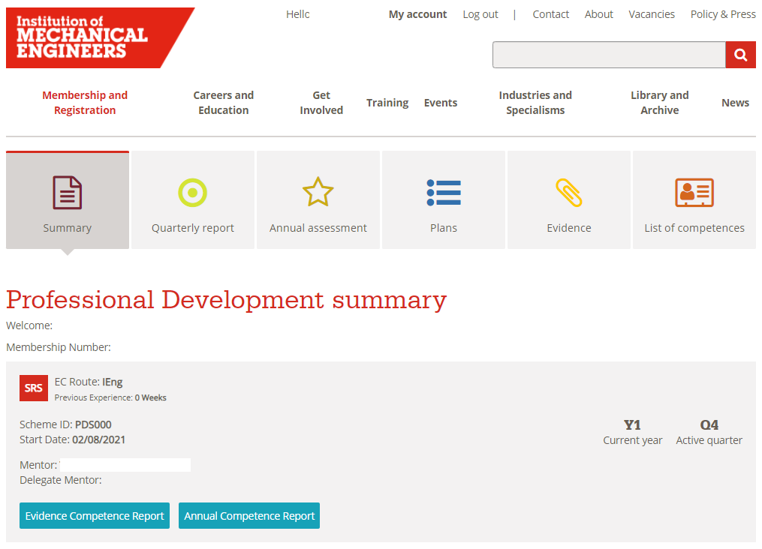

The Summary is your home page. From here you can see your EC Route (the competence framework you are working towards CEng/IEng), the Scheme ID (for SRS this will show as XXX000), your Start Date and your Mentor details. You will also note what your current active year and quarter is.

Summary – shows details of your scheme
Quarterly report - (compulsory)
Annual assessment – (compulsory)
Plans – (optional)
Evidence (optional)
List of Competences - information

The Plans and Evidence are optional tabs but can add value to your report content. It is important to use these functions in the correct order. Ask your mentor to sign off in chronological order:
- Plans
- Evidence
- Quarterly Report
- Annual Assessment.
This ensures the ‘objectives’ from your Plan map into your Quarterly report. This also ensures the ‘evidence’ you submitted auto-maps into your Quarterly Report and auto-maps again to the Annual Assessment. Please note that these Plans and Evidences will not be linked until they are accepted by your Mentor.

TABS | DEVELOPING  ENGINEER’S actions | MENTOR actions
Quarterly Reports  (Compulsory) | Submit Quarterly  Report: (200-500 words) Cut+paste contents of a word doc into the template provided.  Plan objective will be linked if you have submitted a Plan for the quarter.  Evidence, that has been accepted by your mentor will be linked to the quarterly report.  If you chose not to submit Evidence, you must make mention of the competences you have addressed (eg A2; B3; C1; C2; D2). | Review Quarterly reports:  Make relevant comments to provide feedback to the Developing Engineer and the professional review interview panel.  Accept/Return submission
Annual Assessment  (Compulsory) | Create Annual Assessment:  When Evidence has been submitted the competences autogenerate to your report. If no evidence has been submitted, then manually type into the Competence boxes A - E.  Add a personal evaluation of the year before submitting to your Mentor. | Annual Assessment Review+Summary:  Score competencies 1-4. Complete each section of the report, providing relevant comments to provide an assessment of the year and feedback to the developing engineer.  Accept/Return submission.
Plans  (Optional) | Prepare / Edit / Submit Plan:  Write in your objectives for the quarter.  Click to add the competences  from the UK-SPEC  tick list. | Review the Plan:  Add comments or notes  (optional)  Accept/Return submission.
Evidence  (Optional) | Submit Evidence/  Evidence Summary:  Add the relevant UK-SPEC competences you have achieved. These will autogenerate into your quarterly report and annual assessment.  Maximum of 8 pieces of Evidence per quarter. | Review Evidence Submitted:  Score Evidence (optional)  Add Notes or Comments  Accept/Return submission.
List of Competences | Summary of Competences:  Shows summary of assessment scores by competence by year. | Summary of Competences:  Shows summary of assessment scores by DE, by competence by year.

4) CREATE A PLAN (optional)

Click on the Plans tab; Plan templates are in place for each quarter. The Status column shows either Submitted, Accepted or New. Click on a Plan e.g., “Y1 – Q3 - Plan” - This opens the Plan template.
- Type in the Plan Objective (max. 500 words) that you intend to cover in this quarter
- Select the competences you intend to cover by clicking on the box “Click to add competences”. Click on the magnifying glass to show a list of competences then click on Select and then Submit
- When you have finished, click on ‘Save’ to amend your plan at later date or ‘Save’ then ‘Submit to Mentor’ if you have finished

The plan is sent to your mentor for review together with an email.

Your mentor will review the Plan, check the competences you selected and may add comments. If your mentor is broadly happy with the plan, he/she will approve it. If the mentor feels the competences are not appropriate, he/she will return the Plan for review. Simply resubmit the Plan with revised competences.

You should focus on these objectives and competences during the quarter. If you do not achieve all the objectives, you simply readdress them in the next quarter. In some cases, a Plan may be cancelled by the mentor (e.g.leaving to go to a new employer; new project etc.). Simply resubmit an updated Plan.

5a) SUBMITTING EVIDENCE against your Plan (optional)

Your professional development will consist of a range of activities (e.g.
project roles; quality management; budgeting and control; various courses, risk assessment etc) all of which will build your competence. You will address competences A, B, C, D and E of UK-SPEC several times, because you gain competence by doing things repeatedly. You can record these competences as part of your portfolio of evidence.

The actual evidence of a particular project is bound to be confidential; therefore, you should not upload company documentation. Your record is portable if you move to another place of work and evidence is usually commercially sensitive. You simply make brief notations and record the competences achieved over the period of a plan (e.g., team leader role; investigated possible cause of failures in xyz; recorded non-conformities; made recommendations on quality and risk; prepared findings in report). You then select UK-SPEC competences. These will auto-map to the quarterly report. You will expand on your comments on these activities in your quarterly report.

Go to the Evidence tab, click on ‘+ Add New’

Give your Evidence a Title (e.g., Causes of Mechanical Failure during acceptance trials)
- Select the category of evidence from the drop-down menu (Project, Report, other)
- Select the quarter that the evidence refers to by clicking on the magnifying glass
- Type in the title of your evidence and location, if appropriate
- Type in your brief comments in the DE Comments box (e.g., team leader role; investigated possible cause of failures in xyz; recorded non-conformities; made recommendations etc) Max. 500 words
- Click ‘Add competences’ to add the competences you achieved during this period
- Click ‘Save & Close’
- You may attach a file to support this evidence
- Click ‘Submit to Mentor’ or ‘Save’ as draft to amend at a later date
- This Evidence (if submitted) has now been auto-sent to your mentor for review with an auto no-reply email

5b) SCORING EVIDENCE
Your mentor will review the Evidence; assess scores 1-4 (optional); add comments (optional). The evidence score 1-4 auto-generates to the Evidence Competence Report, OR, if not scoring evidence, ‘X’ appears in the report. Your mentor may return the Evidence to you to amend and resubmit.

When evidence has been approved, go to the Evidence Competence Report tab. You will notice these scores or ‘X’s are auto mapped to your check sheet. This is a useful ‘at a glance’ gap analysis to show you where you have covered the competence framework in your development profile and where to concentrate further activity.

Note - Evidence scores are for the individual piece of work, not the overall competence.

6) QUARTERLY & ANNUAL REPORTS

Submitting Plans and Evidence is an on-going process. You must submit 3 quarterly reports and an Annual Assessment, for years 1 and 2. For year 3 and 4, quarterly reports for quarter 2 and an Annual Assessment are all that are mandatory. Reports are staggered to ensure you receive monitoring and feedback at each stage. Your quarterly reports (200-500 words) are written in the ‘first person’; providing a synopsis of what you contributed and learnt each quarter, including what you learnt from errors and failures.

Competence is further ‘Monitored’ through the Annual Assessment report. Annual Assessments provide a summary of the period, and the Mentor’s Report and Assessment of competence against UK-SPEC.

Quarterly Reports

At the end of the Quarter, you must prepare a short report of up to 500 words. You can make UK-SPEC more visible in your reports by mapping each paragraph to UK-SPEC (e.g. B1; D1; D2; E4) if you have not submitted evidence.

Go to Quarterly report tab; click on the correct year and quarter to create that report
- Objectives will be linked if you have submitted a Plan for that quarter
- Evidence will be linked if your submitted evidence has been accepted by your Mentor
- Quarterly report - Type or ‘cut and paste’ your pre-prepared report from a word document
- Evaluation of Period - Type or ‘cut and paste’ your pre-prepared report from a word document
- Click ‘Save’ and ‘Submit to Mentor’ to submit it to your mentor or ‘Save’ as draft to amend at later date

If you used the Plans and Evidence tab during this year and quarter, you will notice the system has automatically added the objectives and competences from the Plan and Evidence. These will only appear in the quarterly report if your mentor has accepted the Plans and Evidence before you created the quarterly report. If you have not submitted evidence, the system has no information to generate into the quarterly report. You must therefore add UK-SPEC to each paragraph of your report (e.g., B2; C1; D2; D3; E4). You can use this method of reporting if you prefer not to use the Plans and Evidence tabs, it is entirely up to you.

Your mentor will review the Report and will provide feedback as part of their monitoring role. Your mentor may return the report to you to amend. Once your mentor has approved the report, it will show on your record as ‘Accepted’ together with the date.

Annual Assessment Reports (compulsory)

There is no longer a compulsory requirement for a quarterly report in Q4. Instead, details of the Q4 report can be included within the Annual Assessment.

Go to the Annual Assessment tab
- Click on the required year
- The UK-SPEC competences covered in this period will appear if you have uploaded evidence. You can now make further additions to these if you wish
- Add your comments on how the core competence has been met for each Competence
- Do not leave these areas blank or the mentor will not be able to assess you
- Add a Personal Evaluation of the Year (up to 500 words)
- Click ‘Save’ then ‘Submit to Mentor’ to submit it to your mentor or ‘Save’ as draft to amend at later date
- Please note that if you click ‘Save’ and then ‘Submit to Mentor’ you will not be able to amend the report unless your mentor returns it to you for revision
- The mentor will score your competence level for A B C D E and complete the 4 questions at the end of the report
- The mentor will add their final review and then accept/reject the report.

7) COMPLETING SRS

The Final Annual Assessment Report will normally indicate that you have completed IPD and reached an appropriate level of competence within UK-SPEC criteria (CEng or IEng). However, this depends on the workplace providing you with sufficient opportunity to develop competence and may depend on whether you are actually working at CEng/IEng level. If you or your mentor feels you are not quite ready for registration, it is recommended that you continue recording your development. Complete further quarterly reports until you are ready for registration with the appropriate levels of professional competence. If there are no further quarters available on your schedule, please contact SRS@imeche.org and we will add them for you. You can report up to a maximum Y6Q4.

Our goal is to empower you to take control of your professional development. The SRS provides you with a planned approach to registration as a professional engineer.

We wish you well in your ongoing professional development.

If you have any queries, please contact SRS@imeche.org

